***Note1:*** *All labs are mandatory, and you will be marked on 4, randomly chosen out of 11 labs. These will account for 20% of your overall mark (5% each).*

***Note2:*** *If a marker requests for a specific lab (e.g. Lab 3) and you do not have Lab 3 available, you can ask for another lab to be marked (e.g. Lab 2) but the total marks for Lab 2 will be reduced by 50%.*

***Note3:*** *All the labs should be created on one single document following the* [*provided template,*](https://portdotacdotuk-my.sharepoint.com/:w:/g/personal/val_adamescu_port_ac_uk/EcxluvfBQCdFiOyaQsPbdzYB4OpU8WcLO52Gcvp4L21pVw) *saved in your drive (or computer) and accessible anytime. Labs are individual works, and they will be submitted into Moodle Dropbox - see deadline.*

***Note4:*** *If a LAB is not finished in the scheduled session, you should complete it at your most convenient time by the beginning of the next session.*

***Note5:*** *Use a code editor and do not type into VM directly*

*Online documentation:* [*https://devdocs.io/*](https://devdocs.io/)

# LAB 2 - Normalisation

**Q1. You have the following table (Fig.1) with data. Normalise the table in 1NF (show 1NF) and create the ERD for 3NF, with associated data type.**

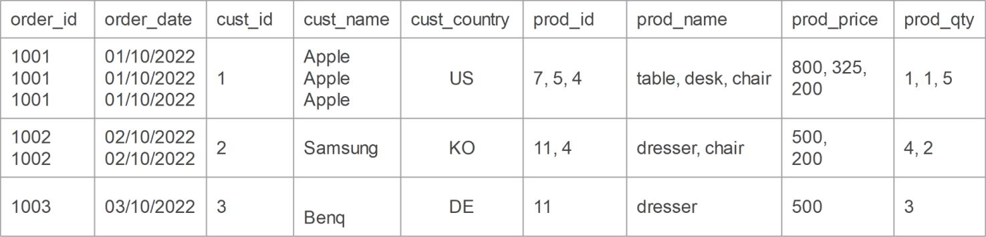

Fig. 1

|  |  |  |  |  |  |  |  |  |
| --- | --- | --- | --- | --- | --- | --- | --- | --- |
| Order_id | Order_date | Cust_id | Cust_name | Cust_country | Prod_id | Prod_name | Prod_price | Prod_qty |
| 1001 | 01/10/2022 | 1 | Apple | US | 7 | Table | 800 | 1 |
| 1001 | 01/10/2022 | 1 | Apple | US | 5 | Desk | 325 | 1 |
| 1001 | 01/10/2022 | 1 | Apple | US | 4 | chair | 200 | 5 |
| 1002 | 02/10/2022 | 2 | Apple | KO | 11 | Dresser | 500 | 4 |
| 1002 | 02/10/2022 | 2 | Apple | KO | 4 | Chair | 200 | 2 |
| 1003 | 03/10/2022 | 3 | Apple | DE | 11 | dresser | 500 | 3 |

**Q2. You are given the following table in 1NF. Normalise data in 3NF and create the ERD with all data type and size.**

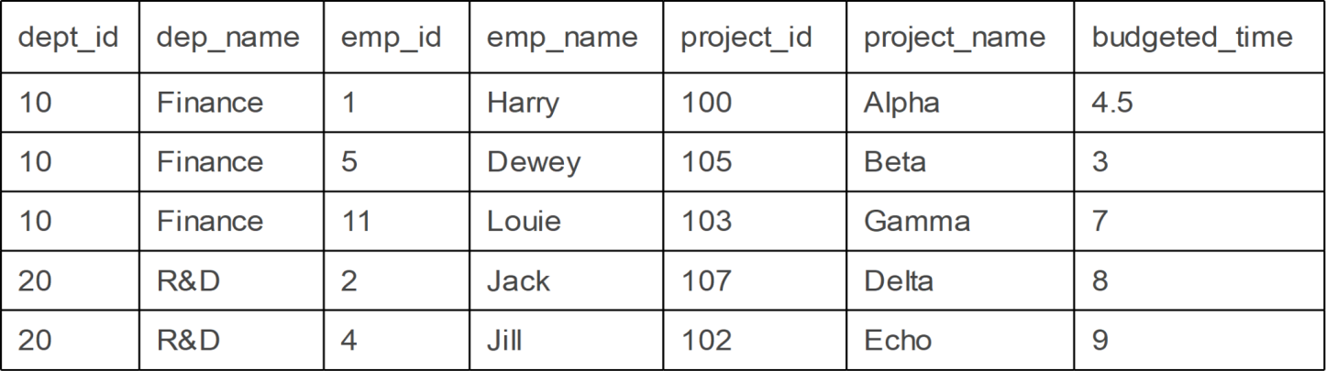

**Q3. University of Portsmouth keeps the following details about a student and the various modules the student studied (not accurate):**

up_number (student registration number to university) stu_name (student name)

stu_addr (student address)

tut_id (tutor id)

tut_name (tutor name)

course_id - (course code)

course_name (course name)

module_id (module code)

module_name (module name)

module_results (module exam result)

**in a relation:**

**Student**(up_number, stu_name, stu_addr, tut_id, tut_name, course_id, course_name, (module_code, module_name, module_results))

**The functional dependencies are:**

course_code -> course_name tut_id -> tut_name up_number, module_id -> module_results module_code -> module_name

Which of the following is a first step of the normalisation of the relation (table) **Student to 2NF**?

*Hint: you can input a quick sample output in a spreadsheet (like Q1) and remove the repeating group.*

1. STUDENT(up_number, stu_name, stu_addr, tutor_id, tutor_name, course_id, course_name)

MODULE(up_number, module_id, module_name, module_results)

1. **STUDENT**(**up_number**, stu_name, stu_addr, tutor_id, tutor_name, course_id, course_name, (module_code, module_results))

**MODULE** (**module_code**, module_name)

1. **STUDENT**(**up_number**, stu_name, stu_addr, tutor_id, tutor_name, course_id, (module_id, module_name, module_results))

**COURSE**(**course_id**, course_name)

1. **STUDENT**(**student_id,** stu_name, stu_addr, tutor_id, tutor_name, course_id)

**MODULE**(**student_id**, **module_id**, module_name, module_results)

**COURSE**(**course_id**, course_name)

**Q4. Based on the previous data sample, what would be a 3NF normalisation? Write just the table names and the attributes as above**

**Q5. You have a SUPPLY table that records details about suppliers, products, and cities where the products are supplied. Acknowledge that a supplier will supply in many cities and a city will have many suppliers.**

**SUPPLY**(supplier_id, supplier_name, product_id, product_name, city_id, city_name)

Normalize the table into 3NF. Assume that the table is already in 1NF, explain why certain attributes had to be separated.

Normalizing into 3nf made it so the city entity was developed on as the brief does not make it clear as to how wide of a supplier the solution is for and product and supplier had to be separated as one supplier can carry many types of products

**Q6. Consider the following ORDER table that records:**

**ORDER**(order_id, customer_id, customer_name, product_id, product_name, quantity, date)

**Normalize the ORDER table to 3NF.**

**Q7. Open your VM and create a new database (lab2). You are given the following data dictionary.**

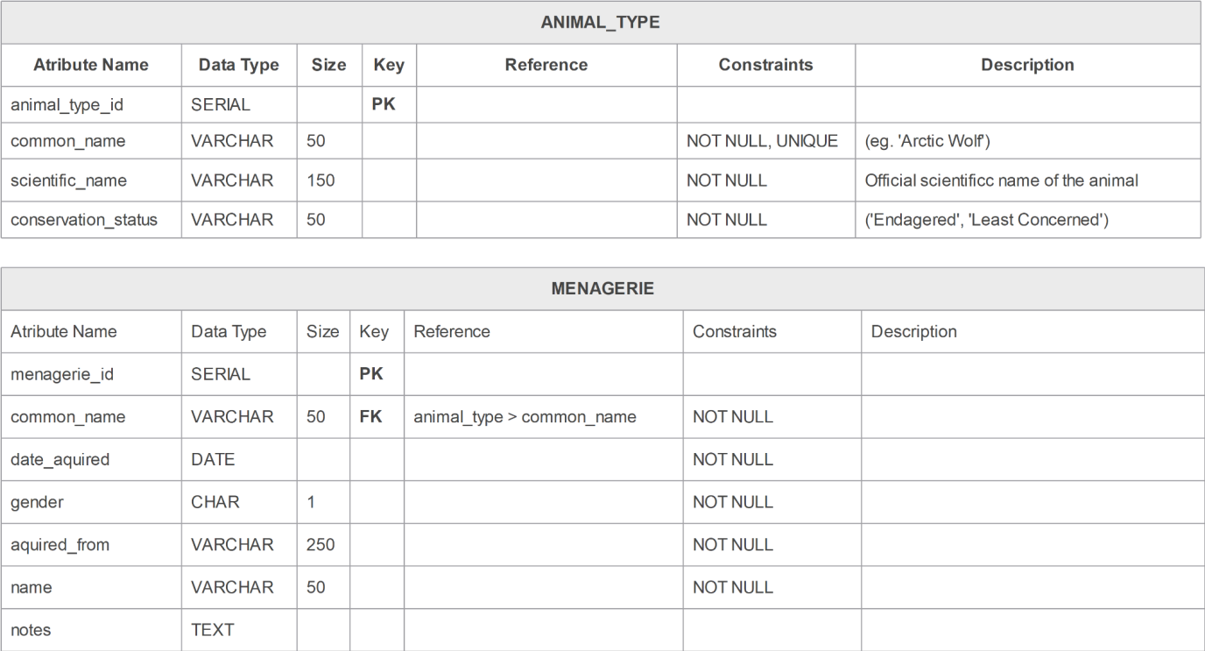

**and the data sample output:**

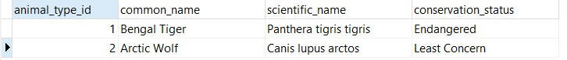

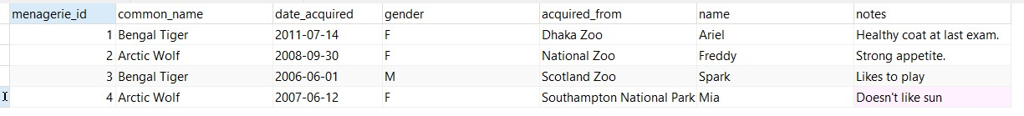

* Write the CREATE statements for tables ANIMAL_TYPE and MENAGERIE, including PKs, FKs, constraints, data type and size.
* Write 6 INSERT STATEMENTS for the following:

○ Common Name: ‘Bengal Tiger’, ‘Arctic Wolf’

○ Scientific Name: ‘Panthera tigris tigris’, ‘Canis lupus arctos’

○ Conservation Status: ‘Endangered’, ‘Least Concern’

○ Acquired Date: ‘14/07/2011’, ‘30/09/2008’, ‘01/06/2006’, ‘12/06/2007’ ○ Gender: ‘M’, ‘F’

○ Acquired From: ‘Dhaka Zoo’, ‘National Zoo’, ‘Scotland Zoo’, ‘Southampton National Park’ ○ Name: ‘Ariel’, ‘Freddy’, ‘Spark’, ‘Mia’

○ Notes: ‘Healthy coat at last exam’, ‘Strong appetite’, ‘Likes to play’, ‘Doesn't like sun’

The output of both tables should be exactly like in provided examples for ANIMAL_TYPE and MENAGERIE .

**Q8. Based on the previous database you have created, list all the animals that are endangered, along with common name, scientific name, animal name and date acquired.**

